|  |
| --- |
| Accident Investigation Report |

|  |
| --- |
| Project Name  Email: [Email Here]  Website: [Website Here] |

|  |  |
| --- | --- |
| Name, Job Title  Email [Email Here] | logo-placeholder |

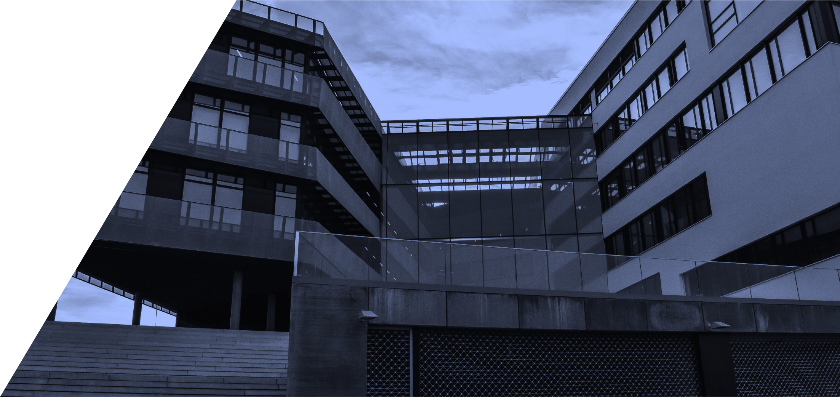

Contents

Executive Summary 3

Introduction 3

Describe your scenario 4

Target audience 4

Report outcomes 5

Conclusion 7

Summary 7

|  |  |
| --- | --- |
| Assessment Report - Submission details | |
| Participant Name: | Jack McLovin |
| Topic: | [Enter topic here] Accident Investigation |
| Unit Code & Name: | [UNIT CODE] – [Unit title] CPC40120OL15SNE(C2) Module 3 – Project Task 2.6 |
| Trainer/Assessor Name: | Yaser Farag |
| Submission date: | ***____ / ____ / ____21/09/2023*** |
| Work submitted:   * nature and cause of injury and compliance with safe work practices from Activity 2.5 * risk minimisation procedure, likelihood of recurrence, cost benefit of additional safety measures * Site Safety Inspector from Worksafe Identified, as well as A Reputable Risk Management Consultancy Company * regulatory authority email as per legislative requirements * written notice/agreement to injured person outlining improvements in safety since incident with effectiveness monitored and reviewed * email to staff outlining new safety measures and strategies to monitor effectiveness, consequences and penalties for breach thereof | |
| Declaration: | In submitting this work I declare that no part of any assessment I submit has been copied from another person’s work, except where clearly noted on documents or work submitted. I declare that no part of any assessment I submit will have been written for me by another person. I understand that plagiarism is a serious offence that may lead to disciplinary action. |
| Participant Signature:  (Insert Name) | Jack Don McLovin |

|  |
| --- |
| Executive Summary *The purpose of this document is to provide a management framework to ensure that levels of risk and uncertainty are properly managed for the remainder of the project. As risk management is an ongoing process over the life of a project, the Risk Register must be considered a ‘snap shot’ of relevant risks at one point in time.* |
| Introduction Report Written By: (Student Name) Jack McLovin  Date: xx/xx/xxxx 21/09/2023  Project Details: Investigations Report for Workplace Incident – Accident Investigation |
|  |

## Describe your scenario

A person has slipped at work while walking on loose broken blockwork laying on the ground and resulted in a torn ligament of the ankle. Someone in charge should’ve recognised the urgency of workplace cleanliness as a priority. It needs to be done by the end of the project, so why not do it now to ensure the safety of workers in the meantime of using the workplace.

## Target audience

Risk management consultancy company, Worksafe inspectors, employees, injured parties, and potential learning/training parties.

## Report outcomes

Insert you Report outcomes in relation to project Questions and Answers into the body of the report here

* The nature of the injury

Ankle’s torn ligament. Likely surgery to re-attach and time off the ankle to heal. Perhaps 1-3 months or more depending on age, or repeat injury

* The activities which caused the injury to occur

Slipping on loose blockwork / leaving loose blockwork on the ground in the path of workers during time of work

* Whether the safe work practices identified in Activity 2.5 have been complied with

Hazard identifiaction is an ongoing procedure, this should have been identified immediately

* What additional actions are required to minimise the risk of the accident occurring again

Clean the ground up of broken materials. Particularly in the path of work.

* An assessment if the likelihood of the accident occurring again if additional safety measures are put in place

Very low, although sometimes the loose broken blockwork is mixed into the dirt and the uneven surfaces can cause the same issue.

* A cost benefit analysis outlining the cost of the additional safety measures compared to the benefits obtained from implementation

Very low cost to keep the place clean when it needs to be done by the end of the job anyway. Very large benefit to keep employees on the job without the need to pay them for their absence and medical.

* Two specialist/expert providers of information for
  + whom the matter should be referred,

Worksafe inspector or Risk management consultancy company

* + the reasons why the matter should be referred,

In the case that the builder doesn’t know how to minimise the risk themselves, and because of legislative requirements to report incidents, accidents, and hazards.

* + An assessment of how seeking specialist advice will ensure compliance with workplace safety requirements

.As long as the specialists know how to solve the issue, as per the information above of cleaning paths in advance of walking and identifying hazards as they arise and regularly, then the risk has been managed and minimised and the workplace safety requirements are ticked.

.

.

.

.

.

## Conclusion

In Conclusion don’t say “she’ll be right” and “just get on with the job”, ensure the place is clean and your pathways are stable, trips slips and falls are the number one injury hazard. We’ve conducted an investigation with Worksafe Inspectors and Risk Management Consultancies to ensure that we minimise the risk for the future and maintain accurate hazard identification and risk removal to prevent a recurrence of this scenario. Daily and even more often cleanups will be required to prevent pathways from encountering trips slips and falls, and the responsibility for cleanup will be designated to the authority in charge of the team producing the hazardous material on the ground.

## Summary

General overview of the report.

Dot point this section of all the areas covered examples may include

* Compliance with the Legislative Requirements
* Installation Requirements
* Installation materials
* Correct Installation methods
* Correct order of worksite project management timelines – ie. clean up as you go
* Seeking expert advice when necessary to minimize future risk
* Reporting and Identifying Hazards as they arise and before they can lead to an incident.